**Increment-2 documentation**

**Objectives:**

This is an android app of different applications with voice alert systems, which is an integration of google maps, voice Alert. One is to provide an alert in a journey and other is to save the list of shopping items and date on which he has to buy and provide alert on that day.

The overall goal is to provide a voice alert system, which reminds them for almost all day to day activities.

The application now provides the Shopping service to the user and he can store and retrieve the information about all the shopping needs to be done from the Remote Database Server.

**Import Existing Services/API:**

1. **Name:** Google Maps API.

**Description:** This API is used in the Journey Tab for its basic operation of route finding to a destination.

In the Shopping Tab in order to reach the store we requested to buy the Item and also the nearest Stores where you can get the same Item.

**URL:** <https://developers.google.com/maps/documentation/javascript/tutorial>

1. **Name:** Google text to speech API

**Description:** This API is used to convert the details entered in Text format to Voice.

Text🡪Speech

**URL:**  <http://weston.ruter.net/2009/12/12/google-tts/>

1. **Name:** Walmart API

**Description:** This API is used to collect the information needed from Walmart.

**URL:** <https://developer.walmartlabs.com/docs>

**Detail Design of Services:**

**Service Description:**

Our project is a Voice reminder system which can be used for multiple purposes. The user has the option to register and create an account in the application.

Here we have 2 types of accounts:

1. Parent account
2. Child account

The main advantage of having these two accounts is that, parent can have access to monitor child account. So that he can get track of information about the child activities. The privileges given to parent can be changed by the child like parent can modify child account or parent can just monitor the account etc.

This app has two main features to use:

1. Journey/Appointment reminder
2. Shopping reminder

**Journey/Appointment tab:**

It will be implemented in Increment-3

**Shopping Tab:**

In this tab, the user has the facility to provide the list of items he needs to buy with the date and time.

So the user gets reminder at the specified date and time.

In this app we have additional features like:

1. At the time of appointment, if he is at some other location, then the app provides him with the directions to the nearest stores where he can buy the items.

Here the user has 3 choices of services that are provided by our Remind Me application.

The user can add a new list to reminder or user can search an item on the store or user can get directions to the store.

**Service 1:**

If the user wants to add a reminder he/she can go to add reminder service and can add a reminder by providing the time and details of the reminder.

**Service 2:**

Suppose if the user wants to search a product on the store, the details of the product should be provided in the search column.

As a result all the list of products related to that name will be displayed using shopping service we implemented.

**Service -3**

Now the user has a wide range of choices to add an item to shopping cart or delete an item in the shopping cart.

The user can save his shopping cart and later he/she can update it by adding deleting more items.

After the desired products are added to the shopping cart user can check out for payment.

**Service -4 (Journey Tab)**

In our Remind Me app we integrate different services in to one application for user benefits.

In our fourth service we provide, user can slide to Journey Tab. Here the user can provide his journey details like starting and destination address and can get google maps and time that takes for his journey.

Apart from the routine applications that are available already this service we provide has an additional functionality of setting a reminder for the journey.

This android service is under construction.

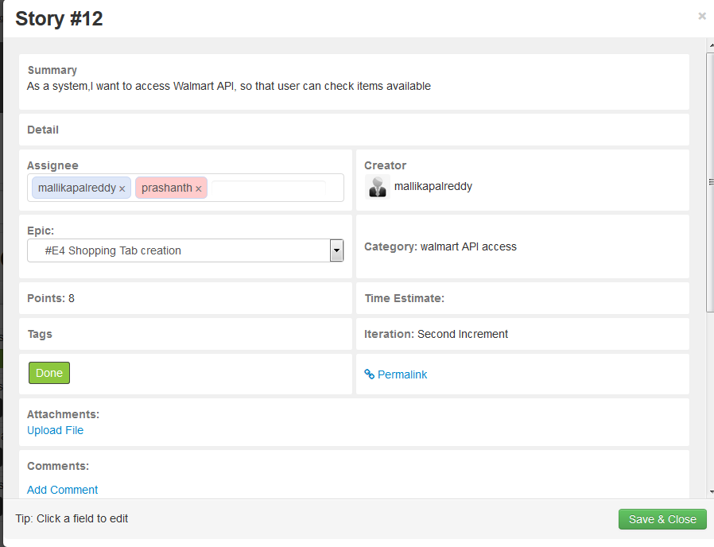

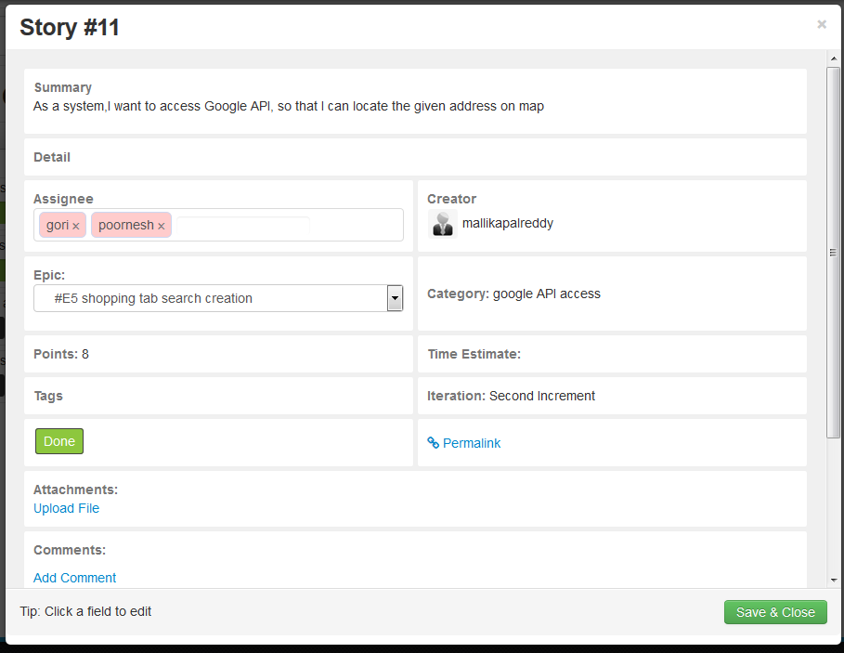

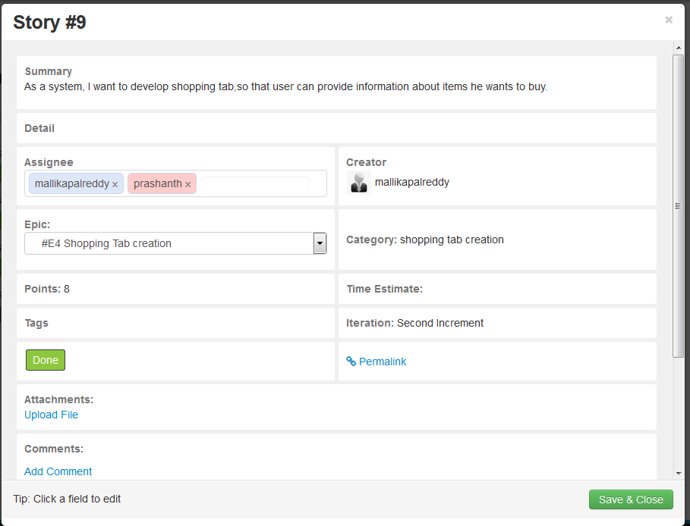

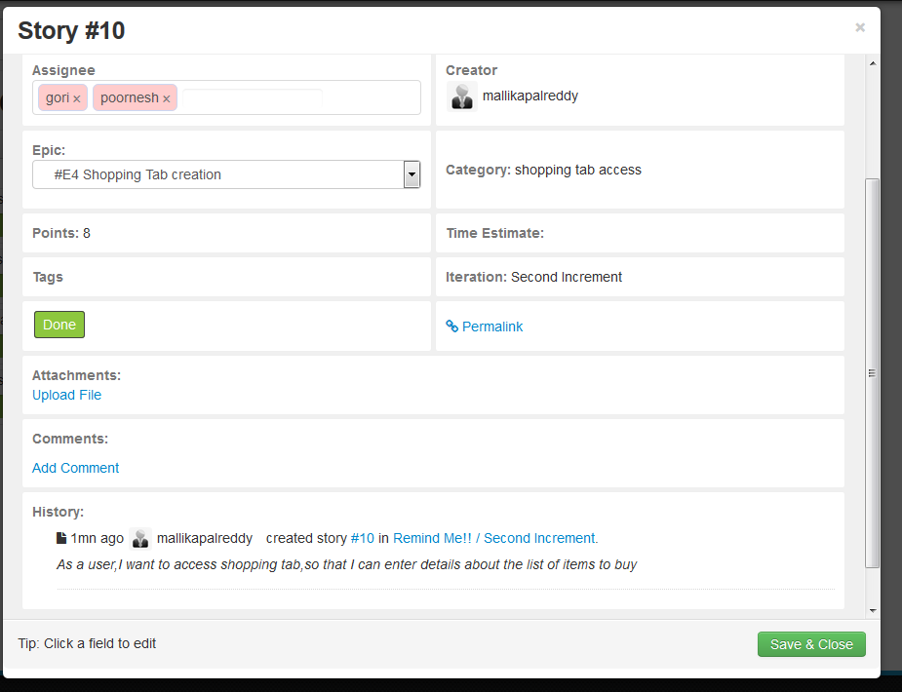

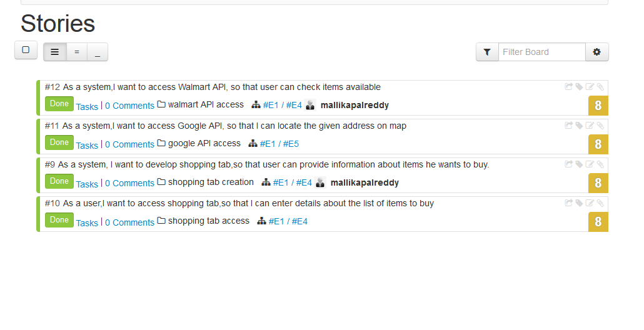

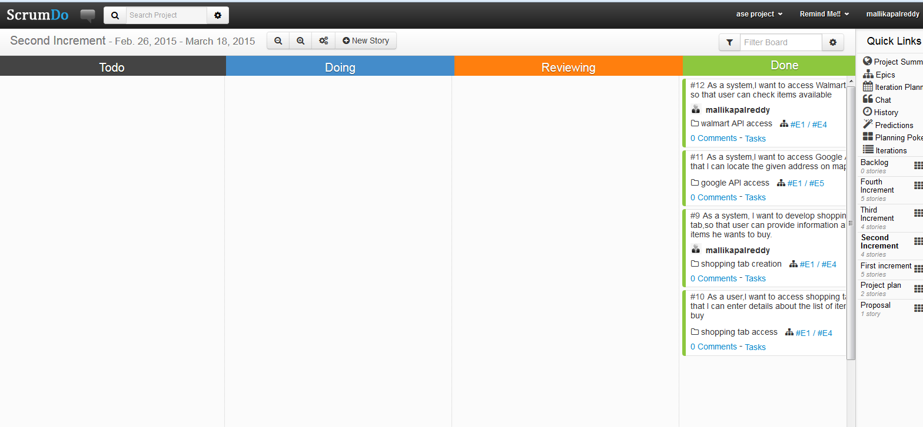

**Architecture:**

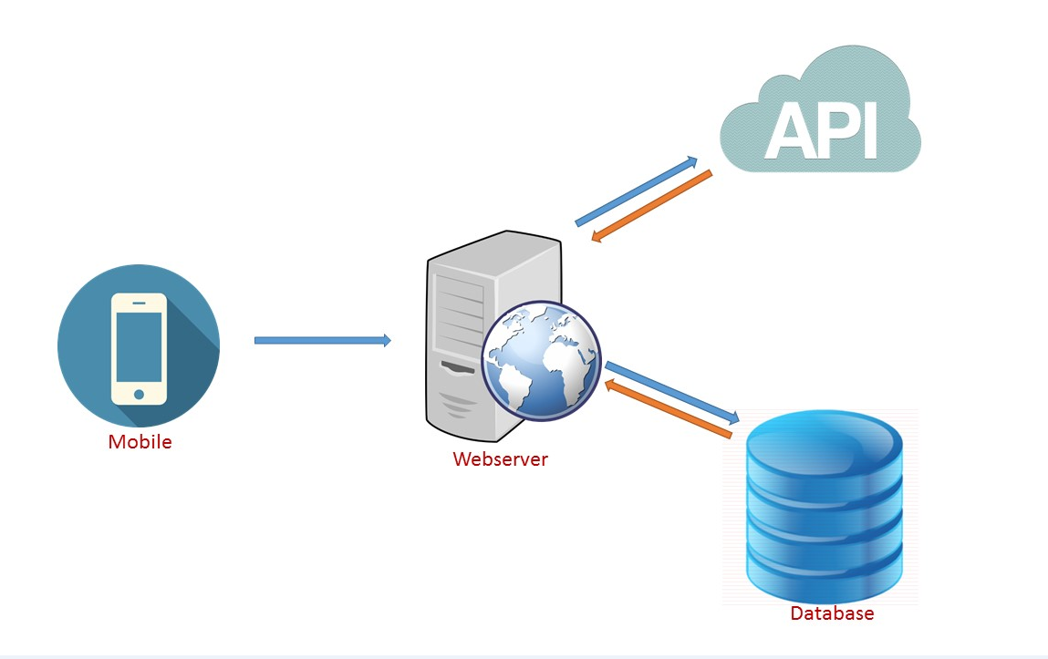

For this app we are using Google Maps API, Text to Voice API.

**Class Diagrams:**

**Login Page**

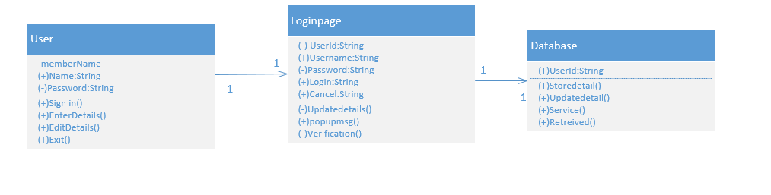

**Registration Page**



**Sequence Diagram:**

**Login Page**



**Registration Page**



**Shopping Tab**

**Class Diagram:**

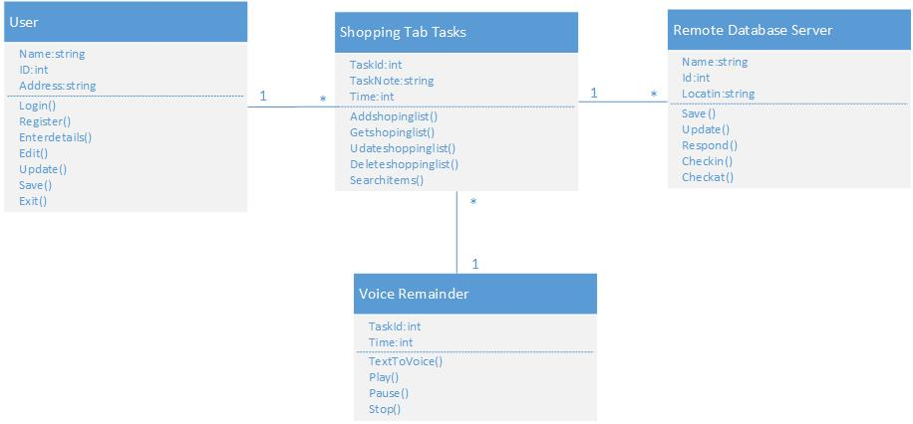

**Sequence Diagram:**

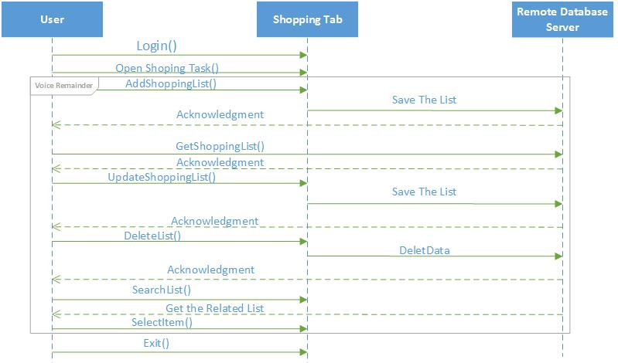

**Design of mobile client interface:**

**App Icon on Mobile:**

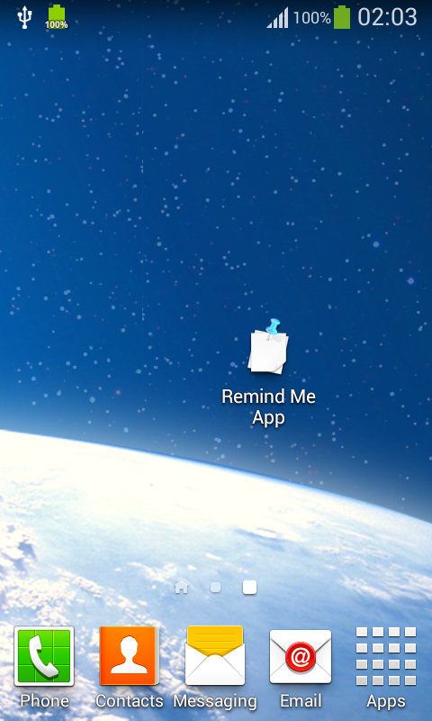 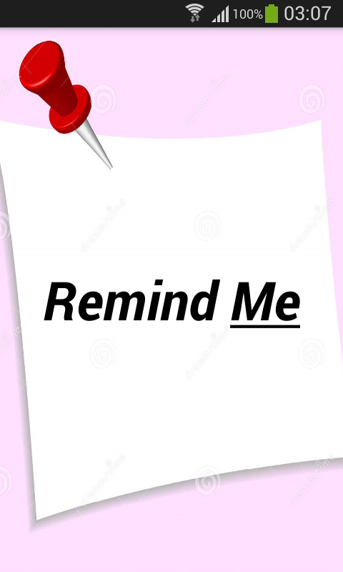

**Login Interface:**

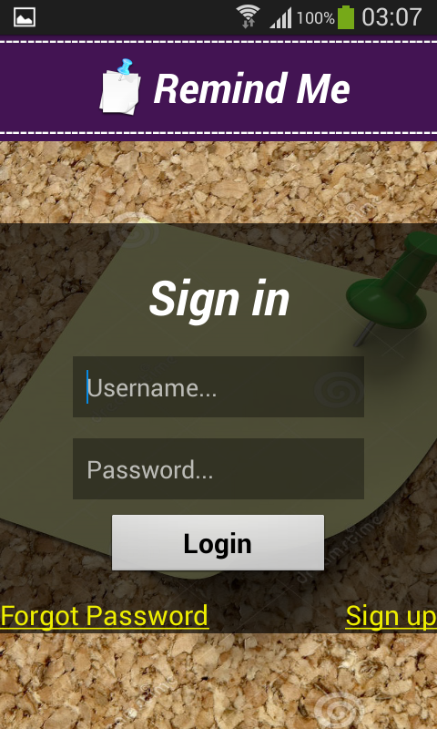 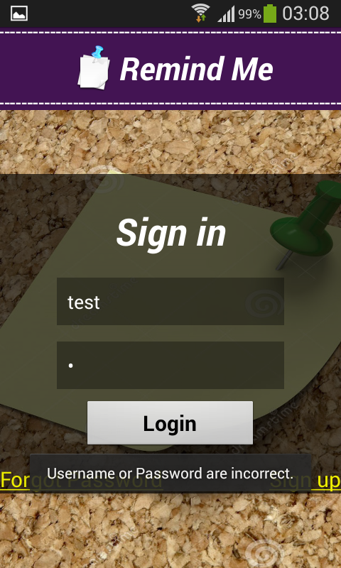 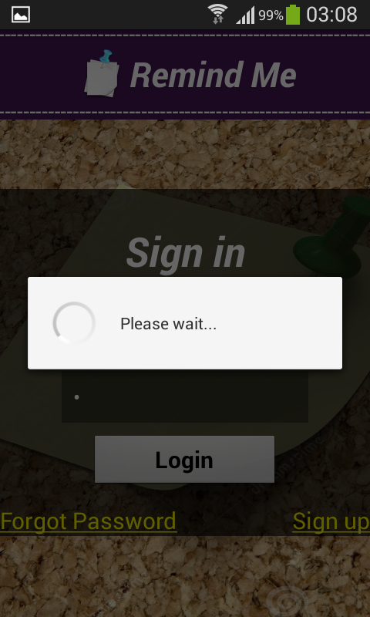

**Register Interface:**

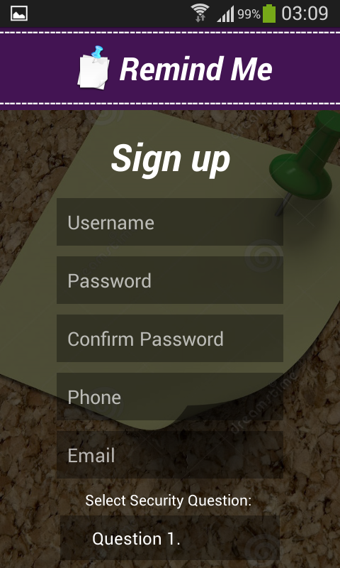 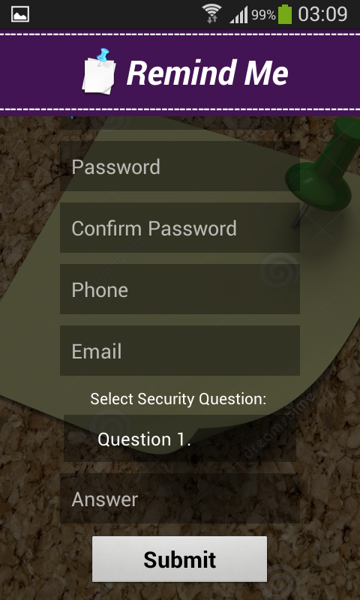

**Shopping Tab Interface:**

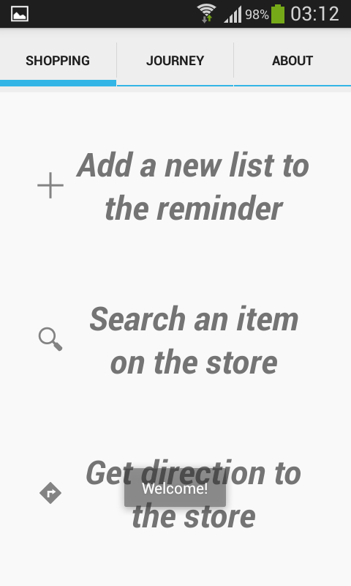 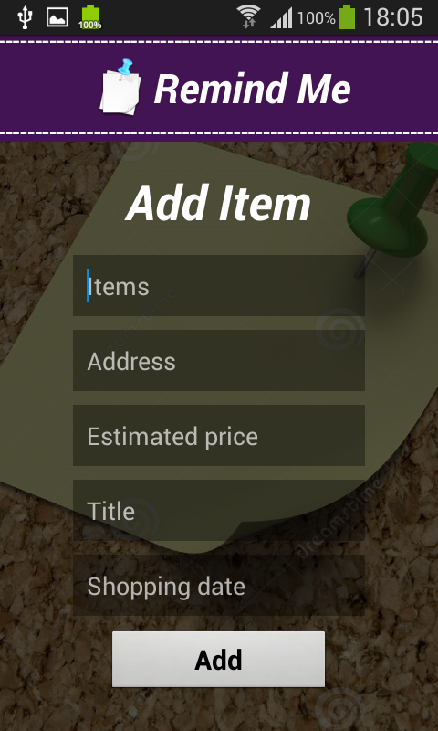 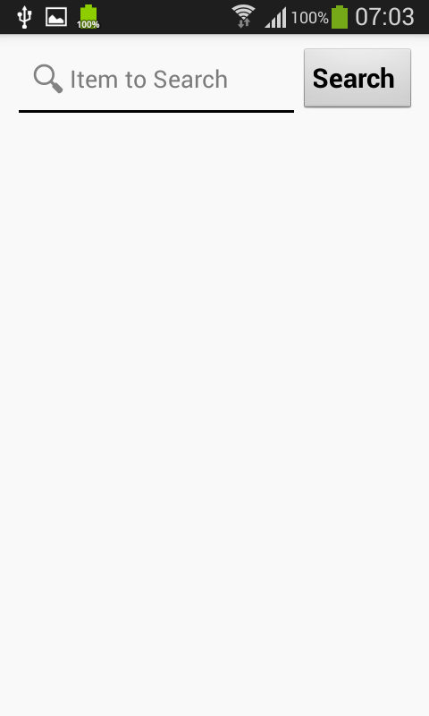

**Implementation:**

**Implementation of REST Services:**

We are implementing rest services using advanced rest client, with Mysql database.

We used Java with Jersey framework to work on this.

**Implementation of User Interface:**

**Login Page:** Once the user selects Login Button, he gets directed to Login Page.

If the user enters correct details, then Login successful message gets displayed.

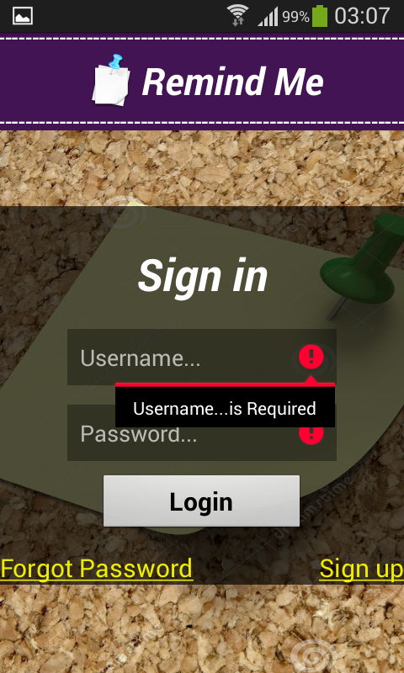 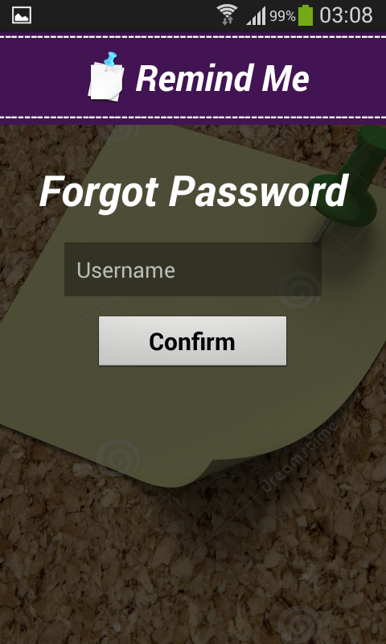

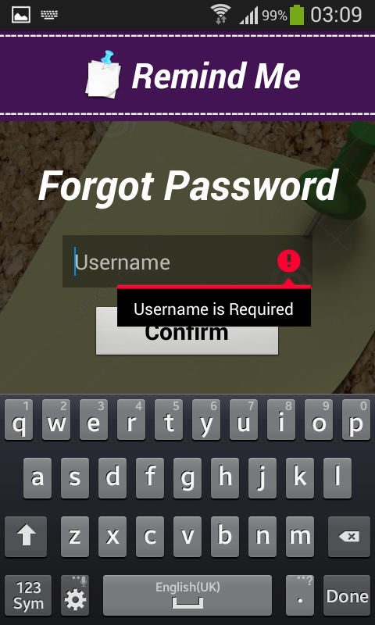 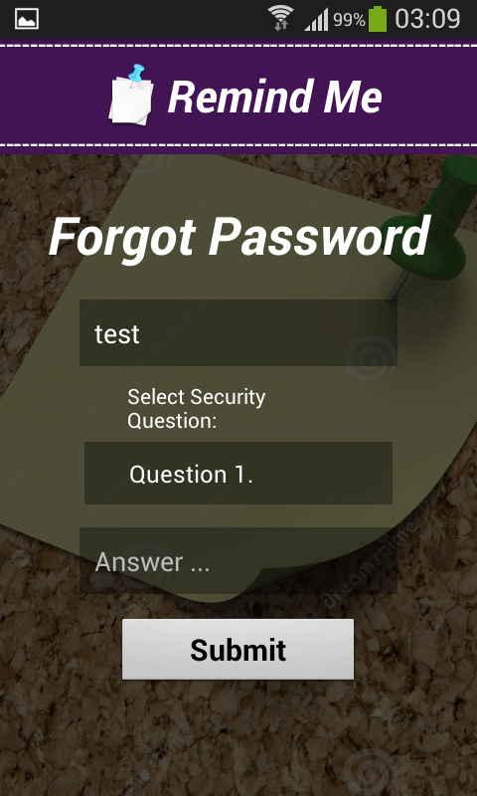 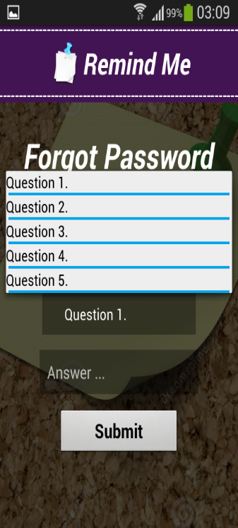

**Implementation of Register Page:**

**Registration Page:** Once the user selects the Registration tab, the user s directed to this page, where he enters his details for registration.

The registration is done successfully only if the user enters same password and confirm password, else he gets a message saying “Passwords doesn’t match”.

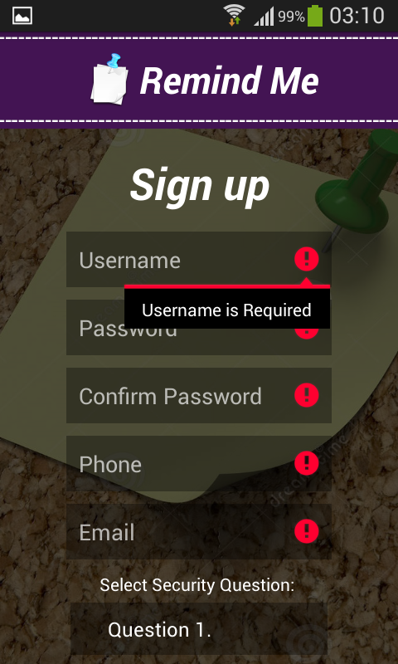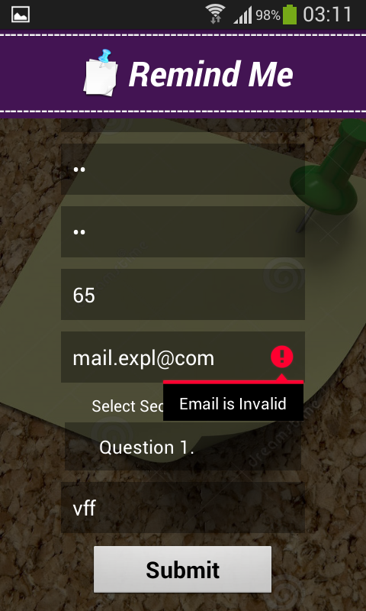

**Implementation of Shopping Tab:**

 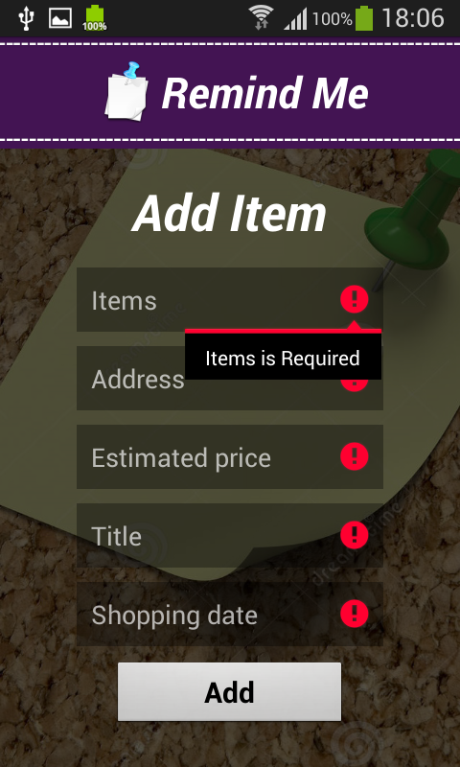

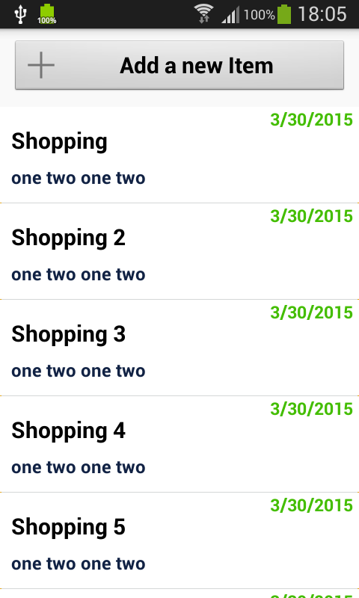 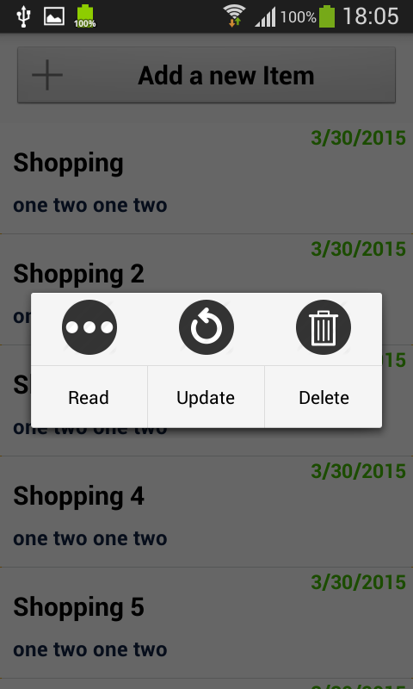

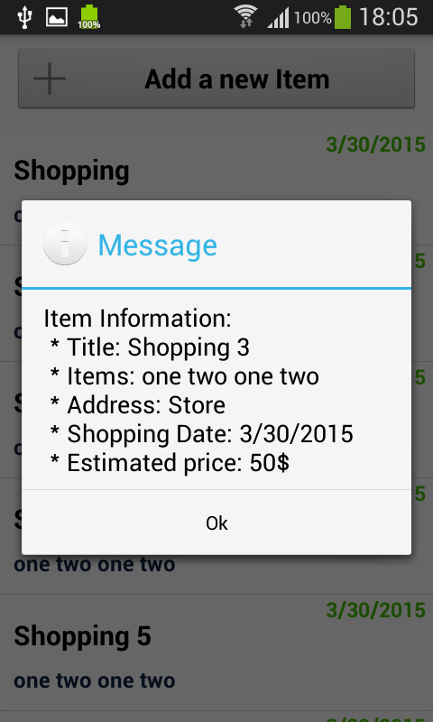 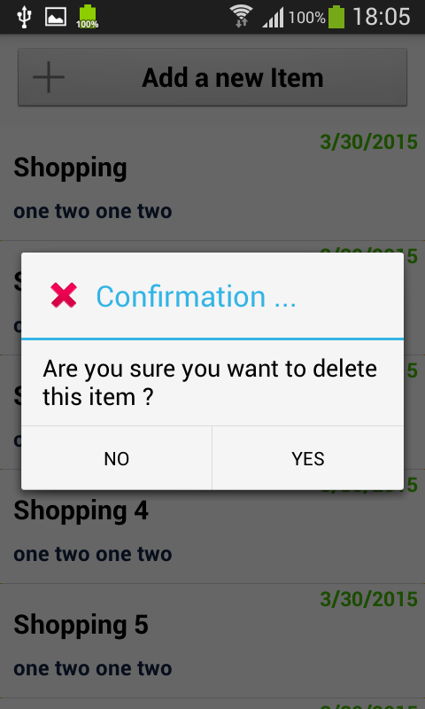

**Implementation of Search Service:**

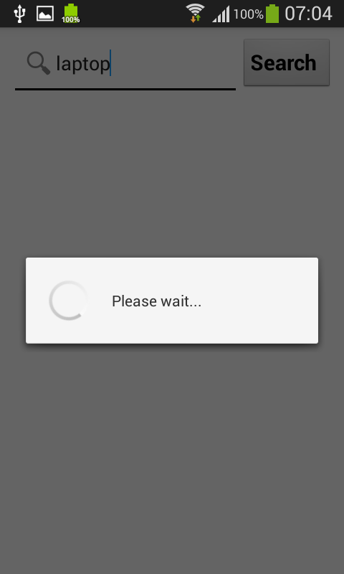

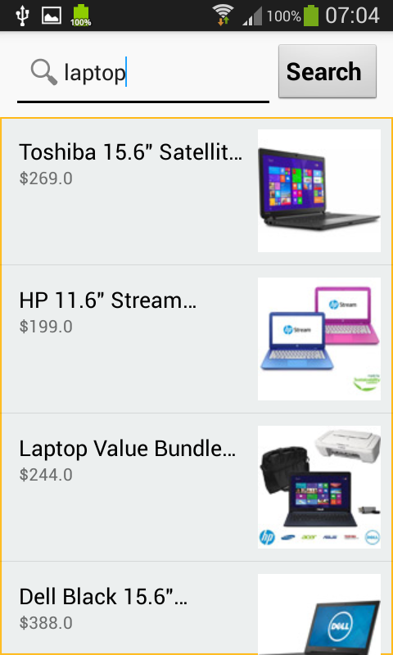 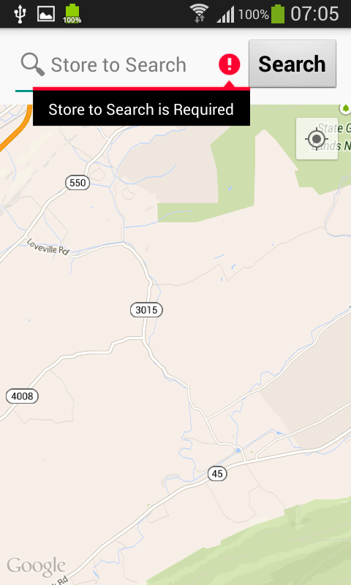

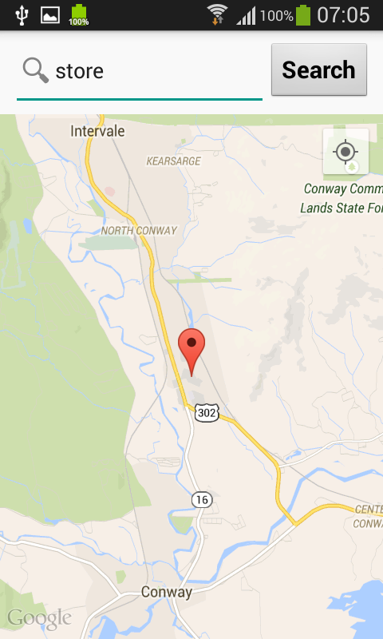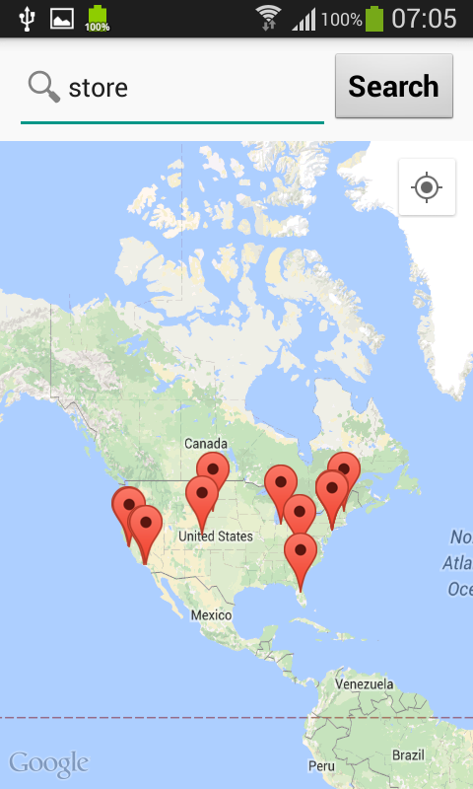

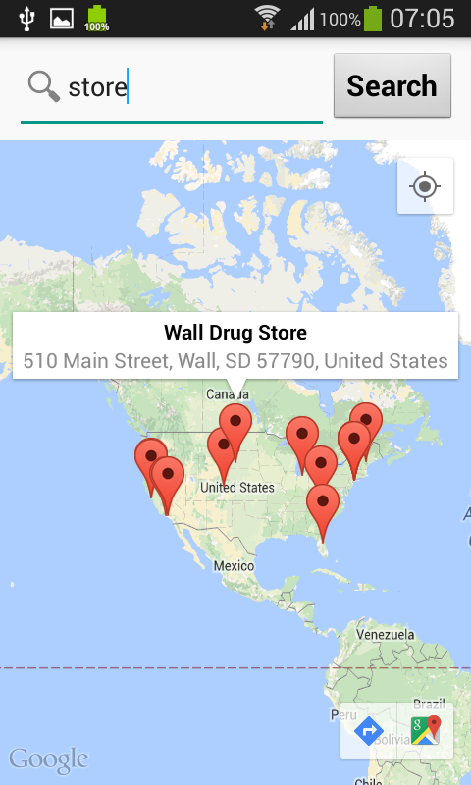

**Implementation of Unit Test Cases:**

**Login page:**

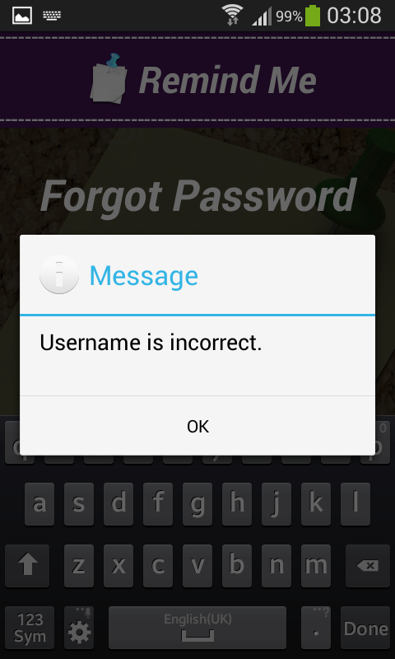

**Register Page:**

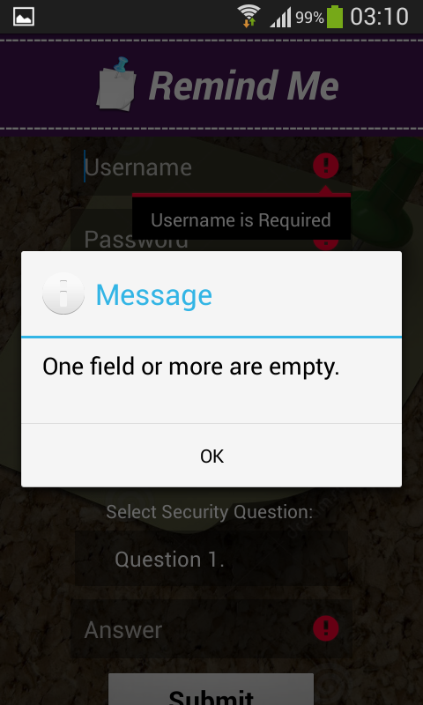 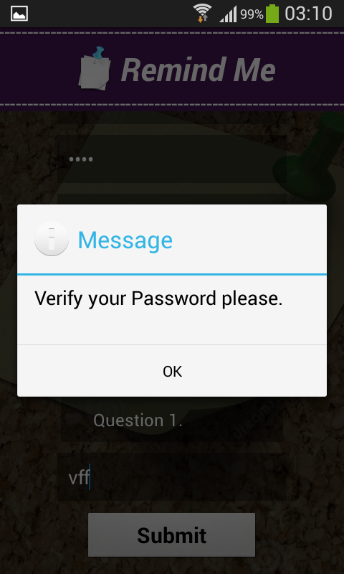

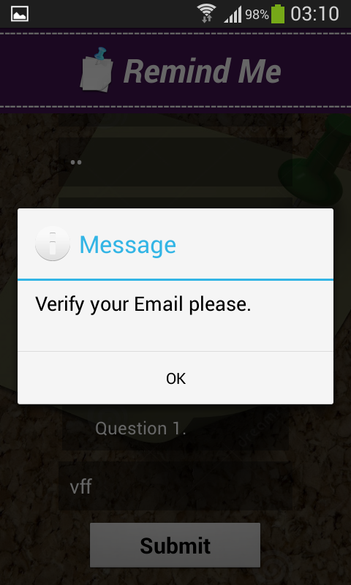

**Shopping Tab:**

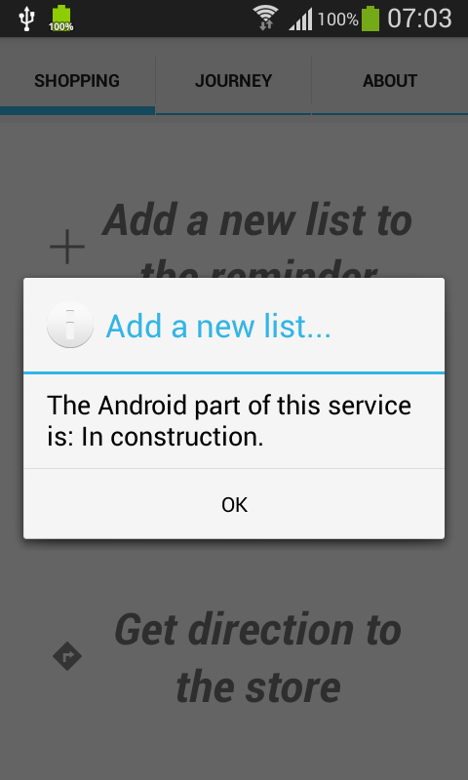

**Layouts for the Journey Tab Service:**

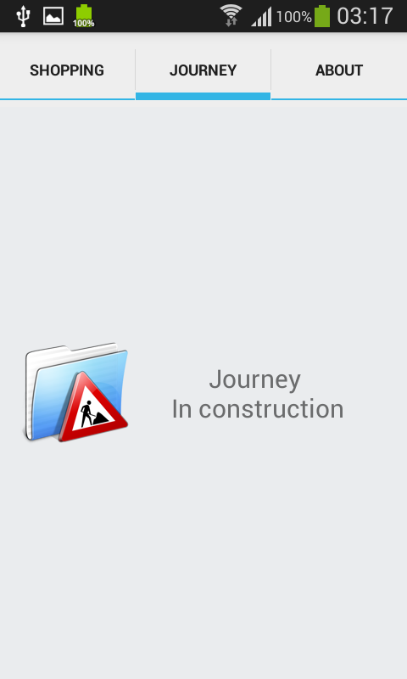 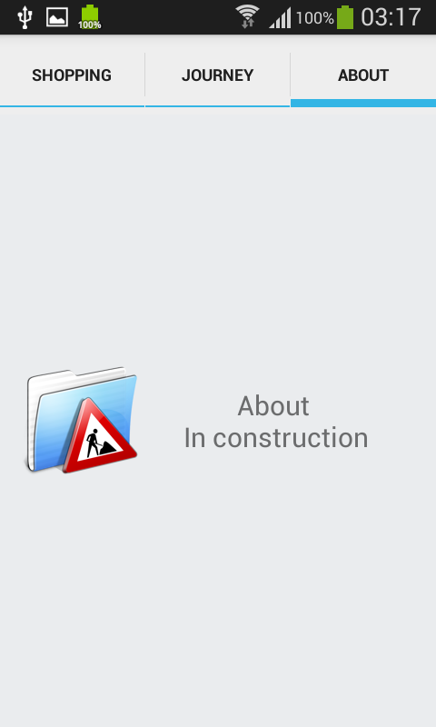

**Testing:**

For testing our Remind me application we used google advanced rest client services.

As this provides all the post, get and other functionalities we require as mentioned above in the document and gives the test result by taking the input instantly, we preferred google advanced rest client services.

Case-1:

Checking Authorization:(Failed)

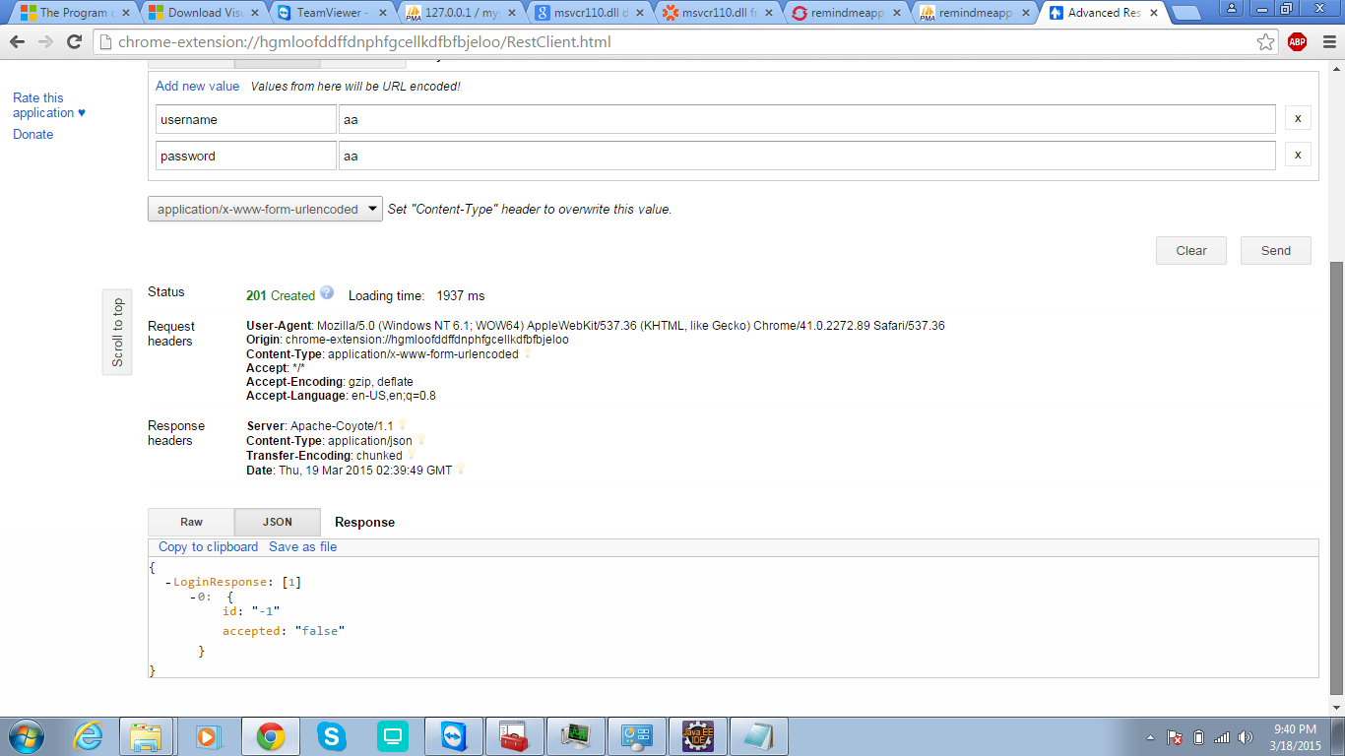

Case-2:

Checking Authorization (Success):

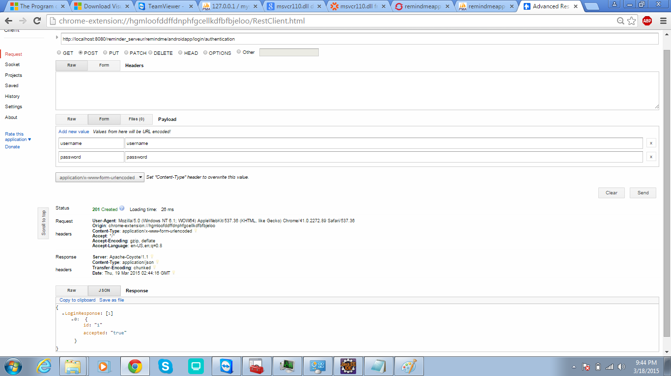

Case-3:

SignUp-success:

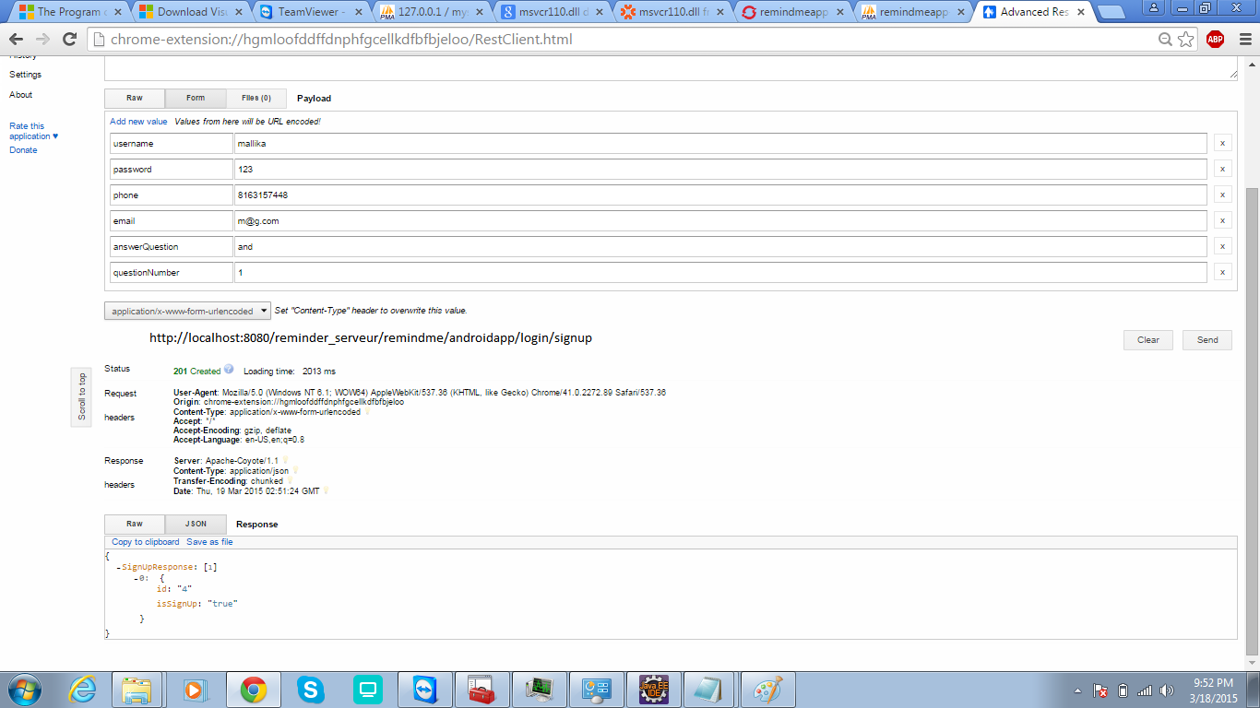

Sign Up-failed:

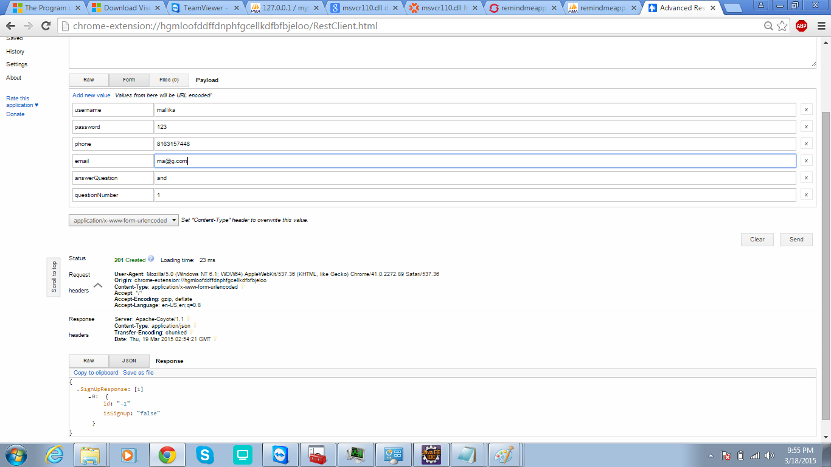

Case-4:

Shopping cart creation-success:

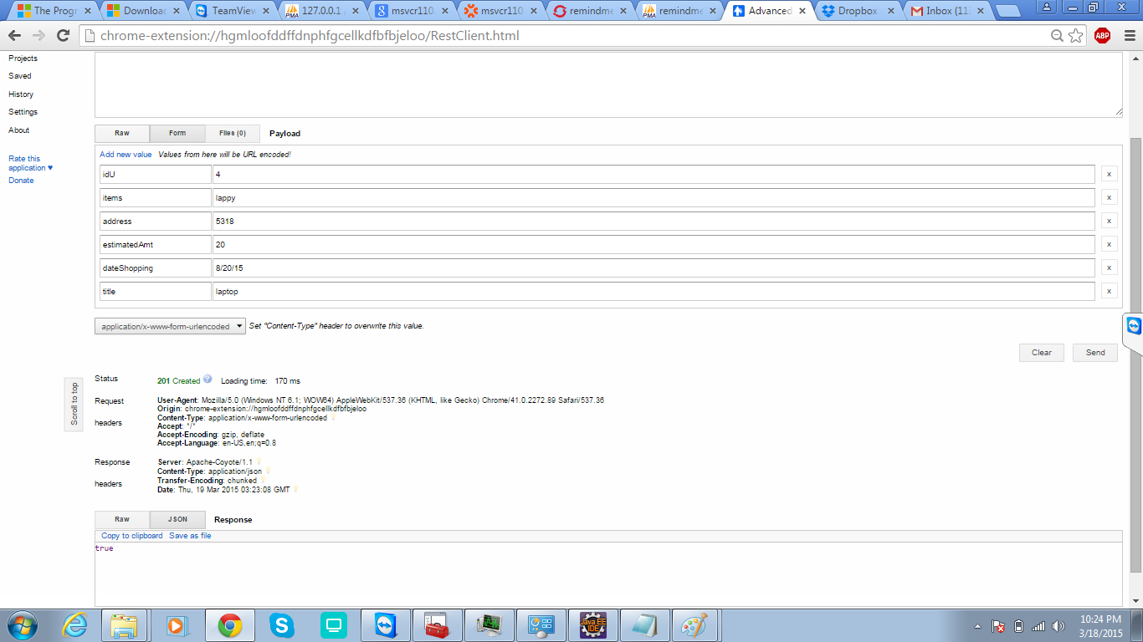

Case-5:

Password-forgot(security query):(failed):

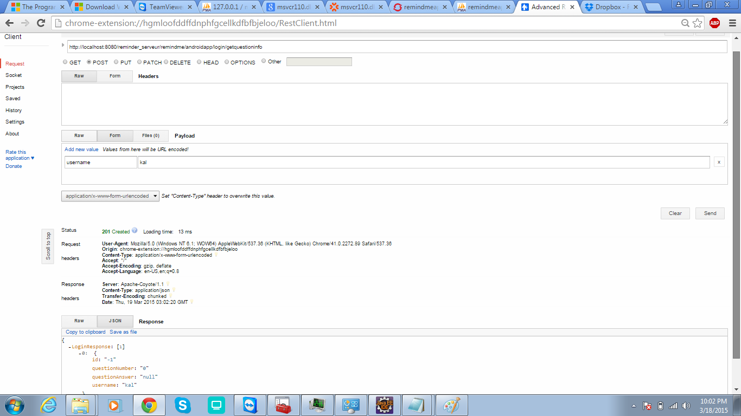

Case-6:

Password-forgot(security query):(success):

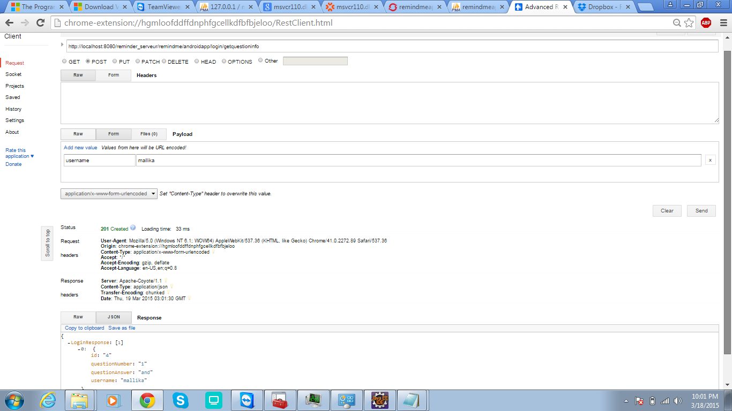

Case-7:

New Password creation-failed:

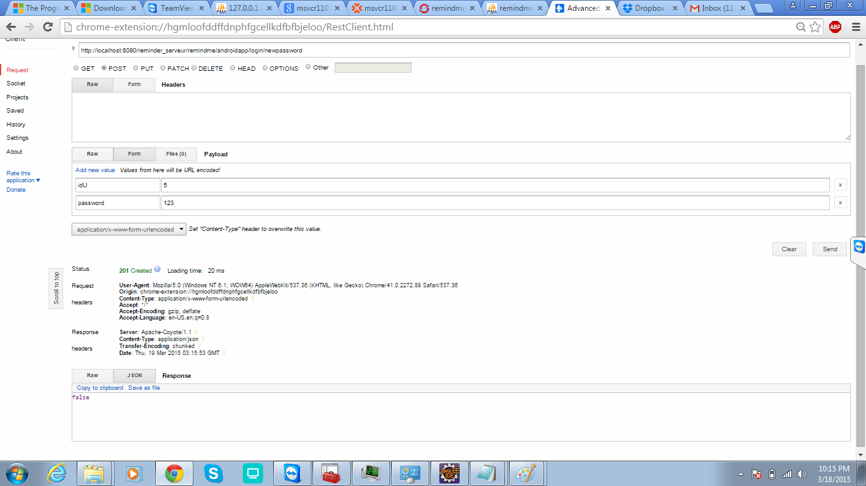

New Password creation-success:

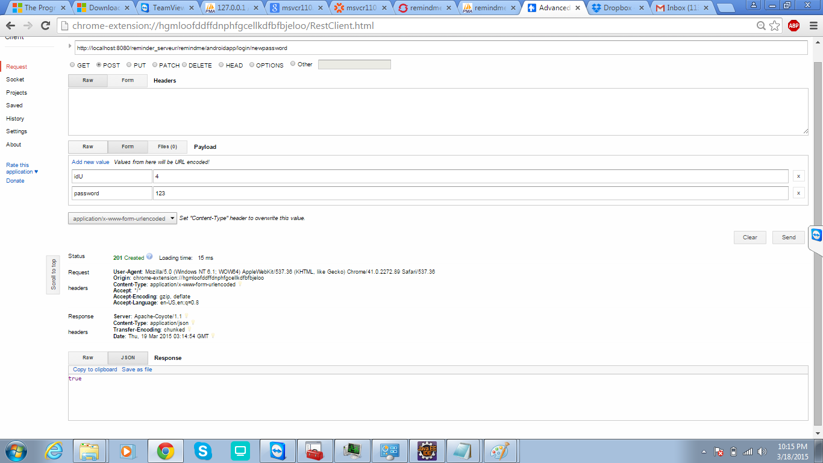

**Scrumdo link:**

https://www.scrumdo.com/projects/project/remind-me/iteration/121769

**GitHub links:**

**source code:**

**report:**

**By**

Venkata Purnesh Gadda (16)

Mallika Palreddy (37)

Prashanth Venna (51)

Mehaboob Gori (54)